Google Classroom for Remote Learning:
Guidance for Pupils
(Link to video: https://www.loom.com/share/126465e59cd34cc98510ce2e18090608)

Contents
3 | When do I need to use Google Classroom?
4 | Your Google login
5 | Taking the Online Morning Register
7 | G-Suite Applications
8 | Google Classroom – logging in
8 | Joining a Class
9 | The Class Page - overview
10 | The Class Page – Stream
10 | The Class Page – Classwork
11 | How to view a piece of classwork (‘Assignment’)
12 | How to Submit Work
12 | How to submit evidence of hand-written work (e.g. in booklets or exercise books)
13 | How to complete a piece of work on a Google Doc or Quiz and submit it
15 | What if my teacher hasn’t asked for work to be submitted?
16 | How can I see a piece of work my teacher has marked?
17 | How to communicate with your teacher
18 | How should I behave online during a ‘live’ lesson?

- When do I need to use Google Classroom?
In school, we will continue to use Show My Homework for setting regular homework.
If you are coming into school, you will not need to access Google Classroom at all.
If you are absent from school because of the coronavirus pandemic, you should log in to Google Classroom to take the register and see what work you need to complete, if you are feeling well.
This table explains what you, your parents and the school should do:
 | Parents | Pupils | School
 | On the first day that a pupil or a member of their household and/or support bubble develops symptoms of coronavirus, or the pupil is advised that they must self-isolate by NHS Test and Trace:
1 | - Keep their child or children at home—they must self-isolate.  - Arrange a test for members of the household with symptoms as soon as possible.  - If their child or children themselves have been advised to self-isolate by NHS Test and Trace, keep them at home for 14 days. | - Self-isolate at home whilst awaiting the outcome of a test.  - Self-isolate for 14 days if they are advised to by NHS Test and Trace.
2 | - Contact reception before 8:15 am to let the school know that their child or children are self-isolating.  - Explain why the pupils need to self-isolate.  - Let reception know when a test will take place, if possible, or that the pupil has been advised to self-isolate for 14 days. | - If they are well enough, check their school timetable for the day. If there is a booklet for those lessons, they should review what they did last lesson and complete the next lesson while they wait for teachers to upload work onto Google Classroom.  - Check Google Classroom regularly during the day, awaiting updates from their teachers.  - Check SMHW at the end of the school day and do their best to complete the homework set for that day. | - Reception staff add the pupil(s) to a register of those who must receive remote work. They email the teachers of the pupil(s) to let them know they must set work on Google Classroom for the day.  - Teachers set work on Google Classroom as soon as possible (given their teaching commitments).
 | Whilst a pupil is at home awaiting the outcome of a test, or self-isolating because of a positive test or because the pupil themselves has been advised to by NHS Test and Trace:
3 | - Contact reception if there is a change in circumstances. For example, if their child or a member of their household has tested positive and how long their child must self-isolate for. Or if the pupil develops symptoms where there were none before and is now awaiting a test.  - Contact the school if they or their child or children need any additional support. | - For each day they are absent, complete the online register.  - Check Google Classroom regularly during the day, completing the work set by teachers for each lesson on their timetable for that day.  - Check SMHW at the end of the school day and does their best to complete the homework set for that day. | - Reception staff maintain and update the register of pupils who must receive remote work.  - Teachers check the register of pupils who must receive remote learning each day.  - They set work on Google Classroom according to the school timetable for the duration of a pupil’s absence.
 | If everyone in the family and/or support bubble with symptoms tests negative, or their isolation period is about to end:
 | - Contact reception to confirm that their child or children will be returning to school.  - Send their child or children into school as soon as possible. In the case of a negative test result which allows their child or children to return to school, this should be on the same day as the result, if their child is well and time permitting. | - Return to school if they are well enough. In the case of a negative test result which allows them to return to school, this should be on the same day as the result, if they are well and time permitting. | - Reception staff remove pupils from the register of those who must receive remote work.  - Pastoral Leads meet with the pupil on their return to school to support their transition back into the classroom. Collect absence letter from pupil.  - Teachers review and discuss with the pupil the work completed during their absence.

If you are absent from school for any other reason (i.e. not related to coronavirus) you should speak to your teachers as normal about catching up with your work.

- Your Google login
To log in to google:
- Go to google.com (or any other google website).
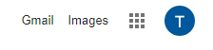
- Click ‘sign in’ in the top-right corner. If you are already signed in to a Google account on that computer, click the initial instead.
- If you are logging in for the first time, enter your
username and password. If you have logged in before,
select your school Google account.
Username = your school ID number@student.bedfordfreeschool.co.uk
e.g. 001234@student.bedfordfreeschool.co.uk
Password = the password you use to log on to school computers, or whatever you have changed it to since.

Remember – the vast majority of you were logging in to Google to complete the daily register when we were away from school!

- Whenever you are using Google for anything related to school, check that you are logged in to your school Google account.

If you are logged in to a personal Google account, you won’t be able to access any school work or the register.

Google has a habit of switching between accounts so if something doesn’t work, check that you are logged in to the right account first!

- Taking the Online Morning Register

When do I need to take the Online Morning Register (OMR)?
On any day when you are absent from school for reasons related to the coronavirus pandemic. These could include:
-You are isolating because you or a member of your household has symptoms
-You are isolating because you or a member of your household has tested positive for coronavirus
-You have been advised to self-isolate by NHS Test and Trace

Should I take the OMR if I am absent for a reason that isn’t related to the pandemic?
No. You and your family should follow the normal absence procedure and a parent or guardian should let the school know you aren’t coming in as soon as possible.
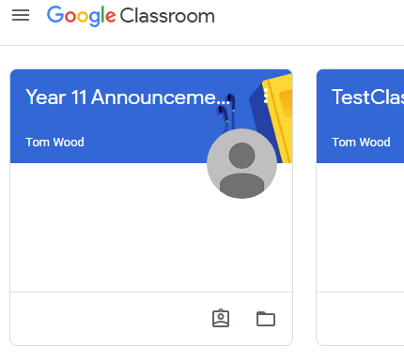
How do I take the OMR?
Go to your classes in Google Classroom.
Open the class ‘Year x Announcements’
At the top of the Class Stream, you will see a message about the OMR with a Google Form attached.
Click the form to open it.
Fill in your details and submit the form when done.
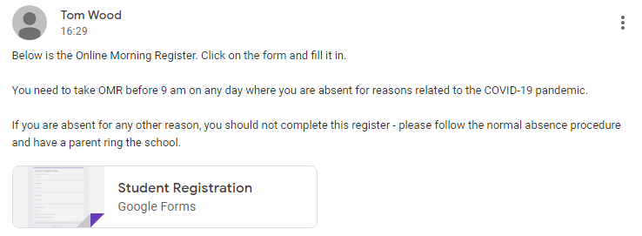

- G-Suite Applications
Logging in to your school Google account gives you access to different apps. The important ones you will need to know about for remote work are summarised below.
After you have logged, click the app launcher in the top-right corner of the screen:
A. Gmail is Google’s email app. If you are working from home, you should check this email as you will receive notifications from Google Classroom. You can use this to email teachers about your work. Teachers email addresses are laid out like this:
First initial+ surname @ bedfordfreeschool.co.uk
e.g. twood@bedfordfreeschool.co.uk

B. Drive is an online storage area. Any work which you do in Google (e.g. on a Google Doc) will be saved here. It is useful as you can access your saved work on any device.

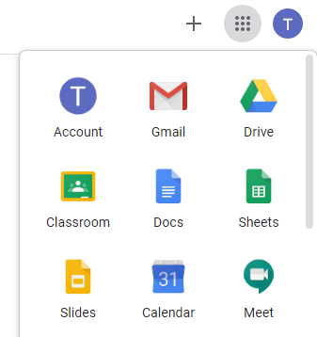

C. Docs is Google’s equivalent of word. It’s completely free to use and your work is saved automatically in Google Drive as you type. This is useful because you can work on a document from any device without installing any other software – you just need to log in to Google.
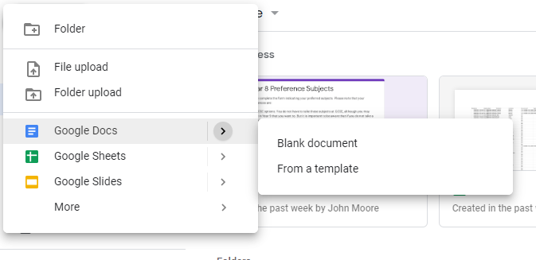
If you want to create your own new Google Doc, clic the big ‘New’ button in Google and select Docs. Work saves automatically, so just close the document when you are finished.
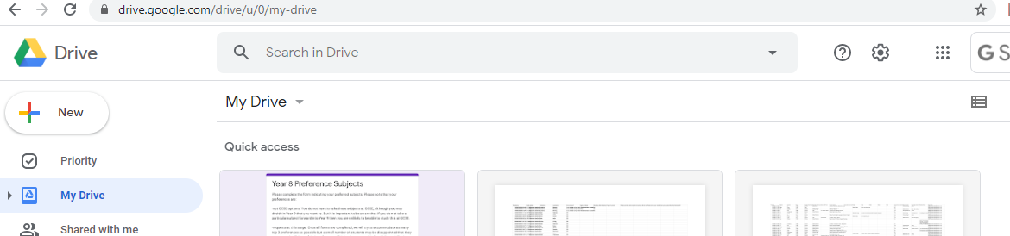
5. Google Classroom – logging in
This is where you can find and submit any remote work set by your teachers.
To access your classes, either click on the ‘Classroom’ app in Google or go to classroom.google.com.
You will need to be logged in to your school Google account to see your classes.
When you log in for the first time, you will need to select your role. Select ‘I am a student’:
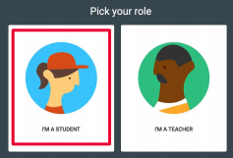

5A. Joining a class
Your teachers should already have added you to your classes. When you log in, you will see a list of classes you have been invited to join. Click ‘Join’: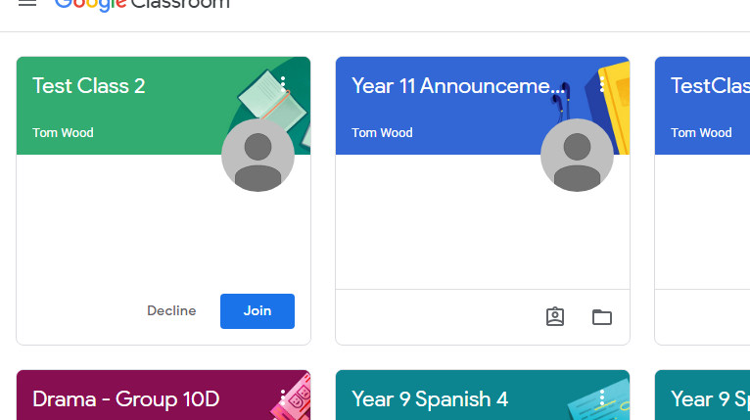

If a class seems to be missing, contact the relevant teacher who will help you.

5B. The Class Page – overview
Click on an individual class to view its page.
3
2
1

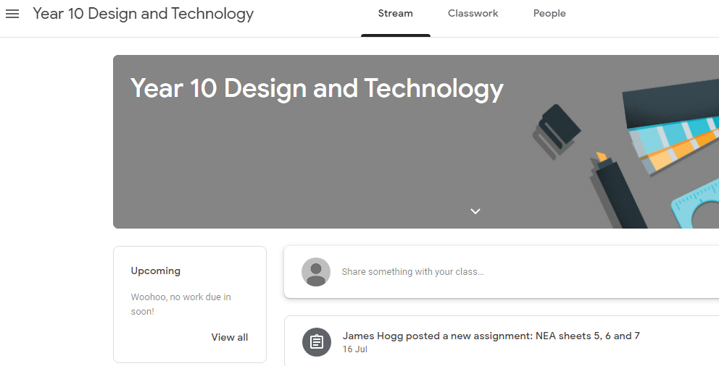

1 = Access the Main Menu by clicking the three lines. Here you can:
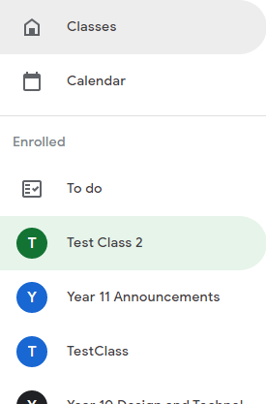
Click ‘Classes’ to view all of your classes

Click ‘Calendar’ to see a calendar of work that is due

‘To do’ to see a list of work you need to complete

Click on an individual class to go to that Class’ page

2 = The class Stream where you can see the latest messages from and work set by your teacher
3 = The Classwork page where you can get more detail about your work, view any attachments and submit your completed work
5C. The Class Page – Stream
When you click on a class, the first thing you will see is its Stream.
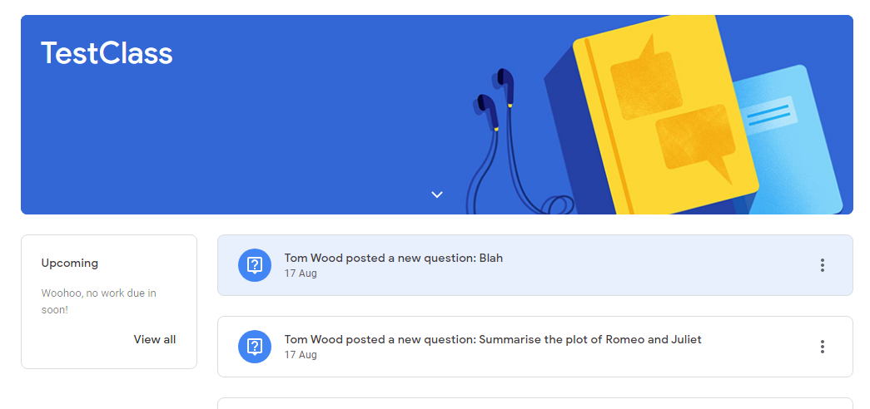
Here you will find updates about the work your teacher has set and any announcements they have made.

5D. The Class Page - Classwork
Probably the most important tab – click on this to view the details of your classwork, download any worksheets or resources and submit work.
4
3
2
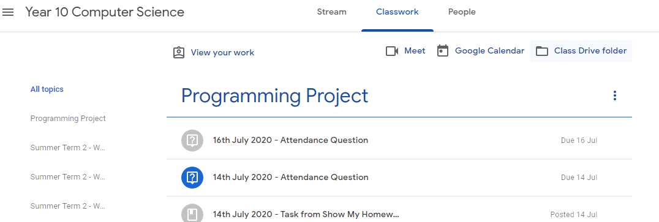
1

1 = List of topics. Your teachers might organise work into different topics. These might be different units of the course, or the week the work was set. Click on a topic to see the work for that topic. It will appear on the right. Click on a piece of work to see more detail.
2 = Click here to see a summary of all the work you have been set and whether you handed it in, on time, late, or not at all.
3 = Click here to see a calendar for that class—when work is due
4 = Click here to see the Google Drive for that class. All the worksheets and other resources that have been posted for that class will be in here.

5F How to view a piece of classwork (‘Assignment’)
Click once on a piece of work (an ‘assignment’) in your classwork list. You will see a summary of the work you need to complete. Click ‘view assignment’ at the bottom to see more detail and submit work.
2
1
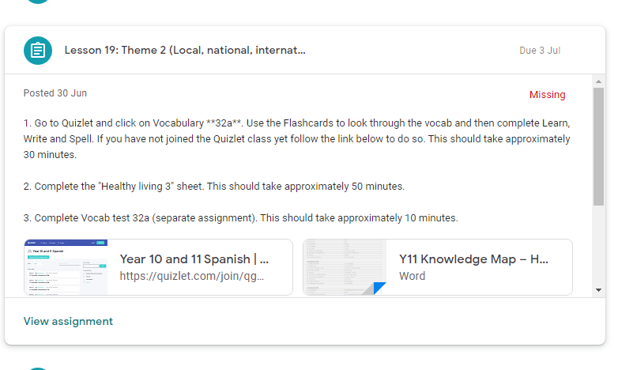
6
5
4
3

1 = Title of the work
2 = Date it’s due
3 = Date it was set
4 = status of the work. “Assigned” = you need to complete it. “Handed in” = you submitted work on Google Classroom. “Missing” = you didn’t submit anything on Google Classroom
5 = Instructions
6 = Attachments such as knowledge maps, links to websites, booklets, worksheets
7 = Click ‘view assignment’ to see more detail and submit work

6 How to Submit Work
Click ‘view assignment’ to see more detail about a piece of classwork and submit it.
Read the instructions on a piece of work carefully to see how your teacher wants you to submit a piece of work. Teachers may set work in different ways depending on the lesson.
They might:
- Ask you to complete handwritten work in a booklet or exercise book
- Ask you to complete work electronically by typing on a Google Doc

6A How to submit evidence of hand-written work (e.g. in booklets or exercise books)
Sometimes, your teacher might ask you to complete written work in a booklet or exercise book which you have taken home. Look at this example:

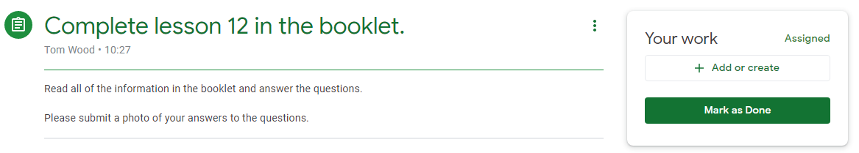
In the ‘Your Work’ box, there is no attachment for you to type on because the teacher wants you to hand-write your answers.

A teacher may ask you to submit a photo of the work you have done.
If you have a mobile phone or tablet, it is easier to use the Google Classroom mobile app to do this. Download this for free on your device’s App store and follow these instructions:
- Find the class in the main menu, go to the classwork page and click on the correct assignment.
- Click the upward arrow in the ‘Your Work’ box at the bottom of the screen
- Click ‘add attachment’
- Click ‘Take a Photo’ and take a photo of your work with your camera
- Click ‘Hand in’
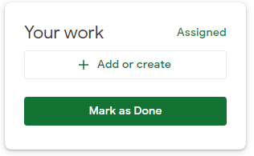
If you can’t download the mobile app, you will need to transfer the photo to your computer. Save your photos in a clearly labelled folder (e.g. “Photos of work”) and make sure it has a clear name (e.g. “English Booklet Lesson 12 21.9.20). Then, take the following steps on Google Classroom:
- On the assignment, click ‘+Add or Create’
- Click ‘File’
- A window will pop up called ‘Insert files using
Google Drive’ (see below)
- Click the ‘upload’ tab

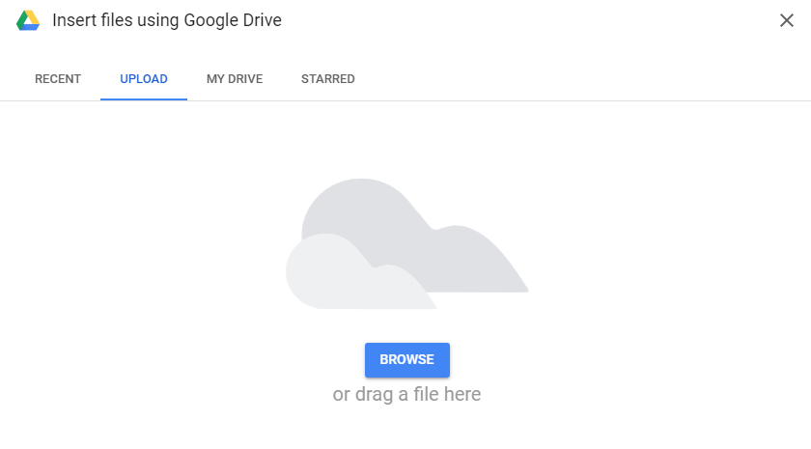
- Browse to find the file of the photo of the work, or drag the file into the box.
- This will take you back to the assignment page. Click ‘Hand In’:

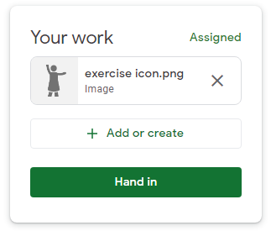

6B How to complete a piece of work on a Google Doc and submit it
Sometimes, your teacher will attach a question or worksheet on a Google Doc for you to type on and submit. Look at this example from Spanish:
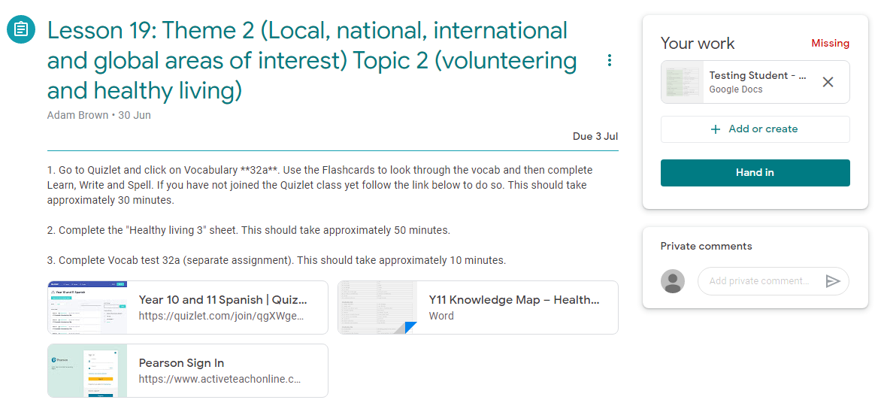
The ‘Your Work’ box contains the Google Doc which your teacher wants you to write on and submit. Simply click on the Google Doc.

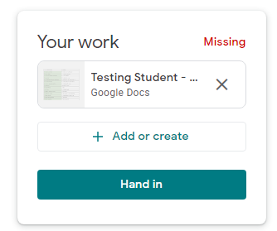

This will open up the Google Doc in a new window. Type your answers onto the Doc:
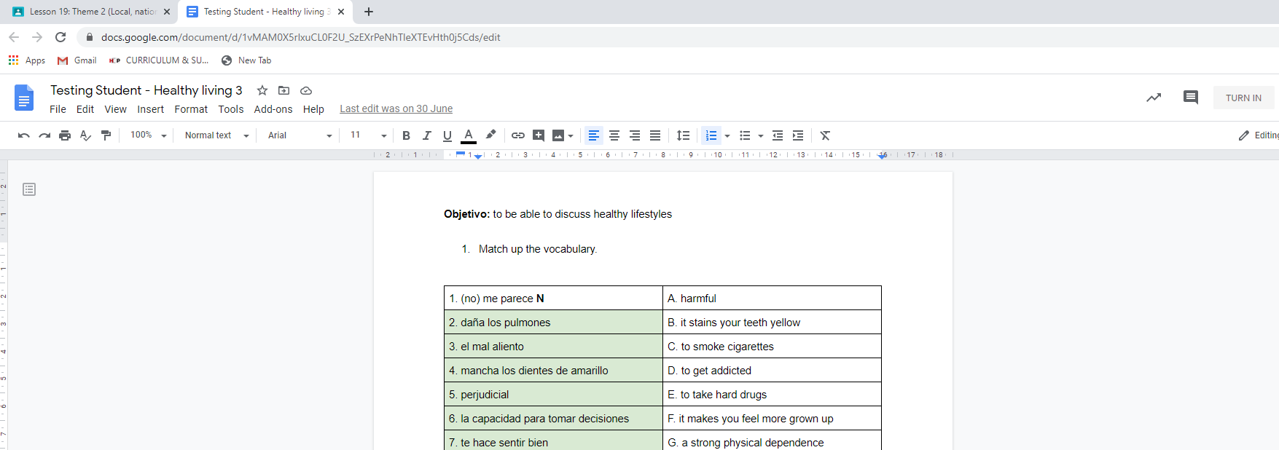
It will save automatically as you type.
Once you are finished, you can close the browser window. The Doc will be saved in your Google Drive.
Back on the assignment screen, when you are ready click ‘Hand in’.

If your teacher has asked you to complete a Google Form Quiz you will see it in the attachments. Simply click the link to open the quiz in a new window. Work through the questions until you reach the end and submit the form.

6C What if my teacher hasn’t asked for work to be submitted?
Sometimes your teacher might not want you to submit anything for an assignment. To keep your records up to date, you should mark the piece of work as completed. Simply click “mark as done” in the “Your work” box on the assignment screen:

7. How can I see a piece of work my teacher has marked?
If your teacher has said they will mark a piece of work, you will get a notification in Gmail once they have returned it. Find the document by going to the Classwork tab (see above) for that class and click on ‘View your work’:

Find the correct assignment and click on ‘view assignment’:
1
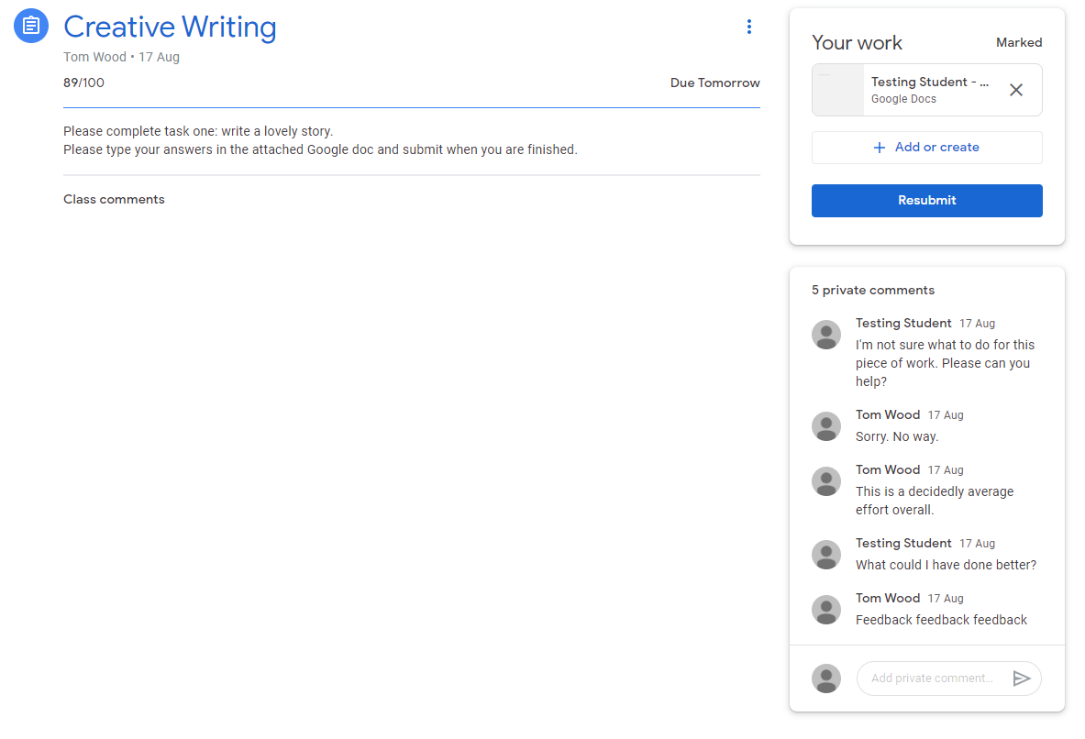
3
2
1 = if you submitted a Google doc as part of the homework, click on it to open it and see if your teachers have left comments on it
2 = your teacher may leave general comments about the work here. You can respond or ask questions.

3 = your teacher might ask you to resubmit your work after making some corrections. You might choose to do this yourself! (Ask your teacher if they wouldn’t mind looking at your corrections)

8. How to communicate with your teacher
Getting in touch with a teacher is easy on Google.
If you have a general query, you can email them:
Click on the Google Apps icon in the top-right corner of the screen and click ‘Gmail’.
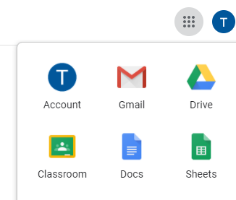

In the top-left corner of the screen, click ‘compose’. Type your email, making sure to address your teacher professionally and politely and signing off by thanking them. Send.
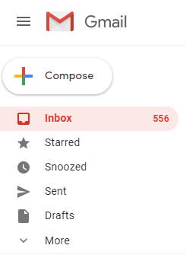
If you want to ask your teacher a question about a specific piece of work, you can do this on the assignment page:

Write a comment in ‘private comment’ under the ‘Your work’ box.

How Should I Behave Online During a ‘Live’ Lesson?
As part of our remote teaching, teachers may invite you to take part in a ‘live’ lesson online using Google Meet.
They will share a link with you in Google classroom to access the meeting.
When you take part in a ‘live’ lesson, you must conduct yourselves appropriately at all times, in the same way you would in a real classroom.
The online code of conduct is as follows. Pupils who don’t follow it may face sanctions in the
When taking part in an online lesson I agree to:
Before and after the lesson
-keep my login details and password safe and never share them with anyone else
During the lesson, at all times
-conduct myself appropriately and follow my teachers instructions, in the same way I would in a real classroom
-be polite and show respect to my teacher and fellow students by never doing, or helping someone else to do, anything which could make them feel uncomfortable, threatened or unsafe, or disrupt the lesson in any way
-to the meeting being recorded, for everyone’s safety
-leave my camera switched on and facing me so that my teacher can communicate with me
-mute or unmute my microphone if asked to so that I can communicate with my teacher
-never share my screen unless directed to by the teacher
-never display an inappropriate or offence profile picture
-dress appropriately for the meeting. I won’t wear pyjamas, anything revealing or anything with an offensive image or slogan
-take part in the meeting in a public part of the house. I won’t take part in the meeting in my or another bedroom.
-report any inappropriate behaviour I see or hear to a member of staff
-work hard and be nice
At the start of the lesson
-have my camera switched on and respond clearly to the register so my teacher knows I am in the lesson
-mute my microphone once I’ve responded to the register
At the end of the lesson
-leave the lesson immediately when asked to by my teacher
same way as they would in school and may not be allowed to take part in online lessons.

